Date:28/01/2026
EXP NO 18. Demonstrate Storage as a Service (SaaS) create and configure a new VM Image in any Public Cloud Service Provider using Azure.

AIM:
To Demonstrate Storage as a Service (SaaS) create and configure a new VM Image in any Public Cloud Service Provider using Azure.

Procedure:
Step 1: Log in to Azure
- Go to https://portal.azure.com and sign in. Step 2: Create a Resource Group
- Click Resource Groups → + Create
- Name: SaaS-Storage-RG
- Select nearest Region
- Click Review + Create → Create Step 3: Create a Storage Account
- Click Create a Resource → Storage → Storage Account
- Fill details:
  - Resource Group: SaaS-Storage-RG
  - Storage Account Name: saasdemostorage123
  - Performance: Standard, Replication: LRS
- Click Review + Create → Create Step 4: Create Container & Upload File
- Open the storage account → Containers → + Container → Name: mycontainer
- Open mycontainer → Click Upload → Select a file Step 5: Access File Publicly
- Click the uploaded file → Generate SAS / URL
- Copy the link → Open in browser or share

Design:

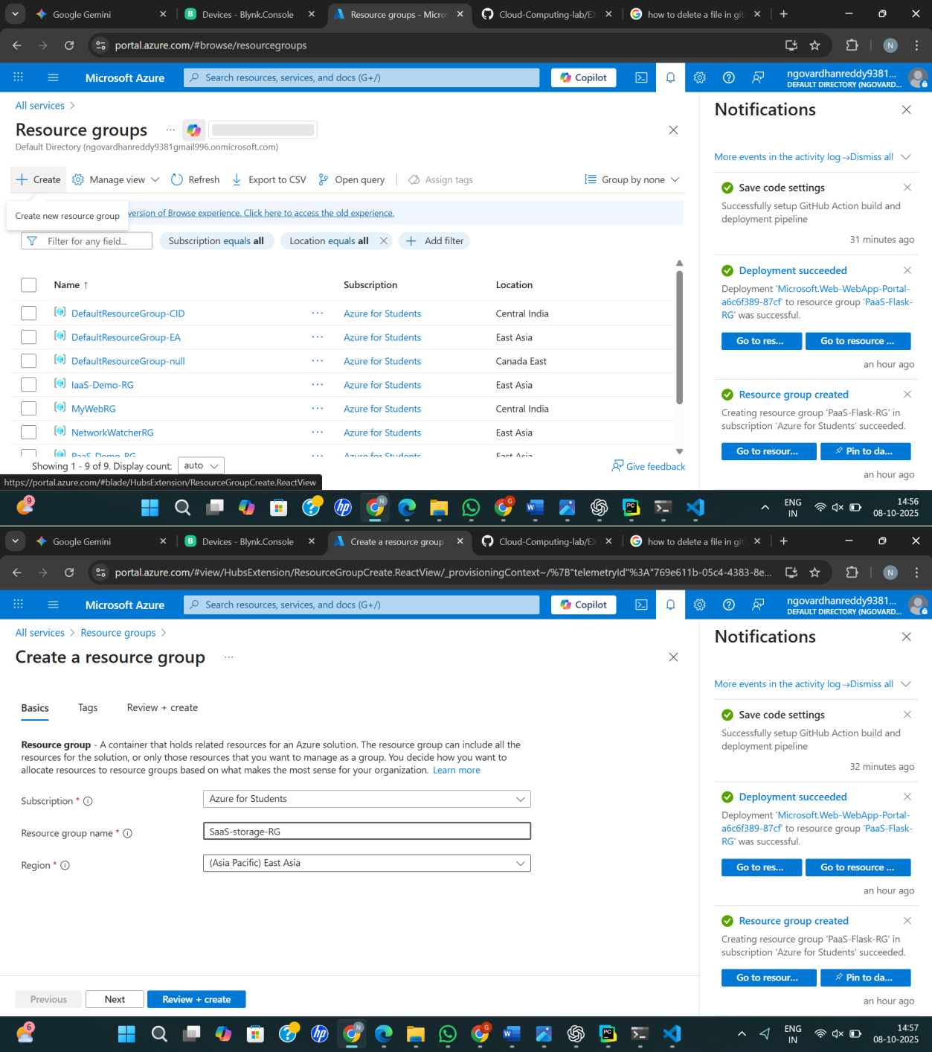

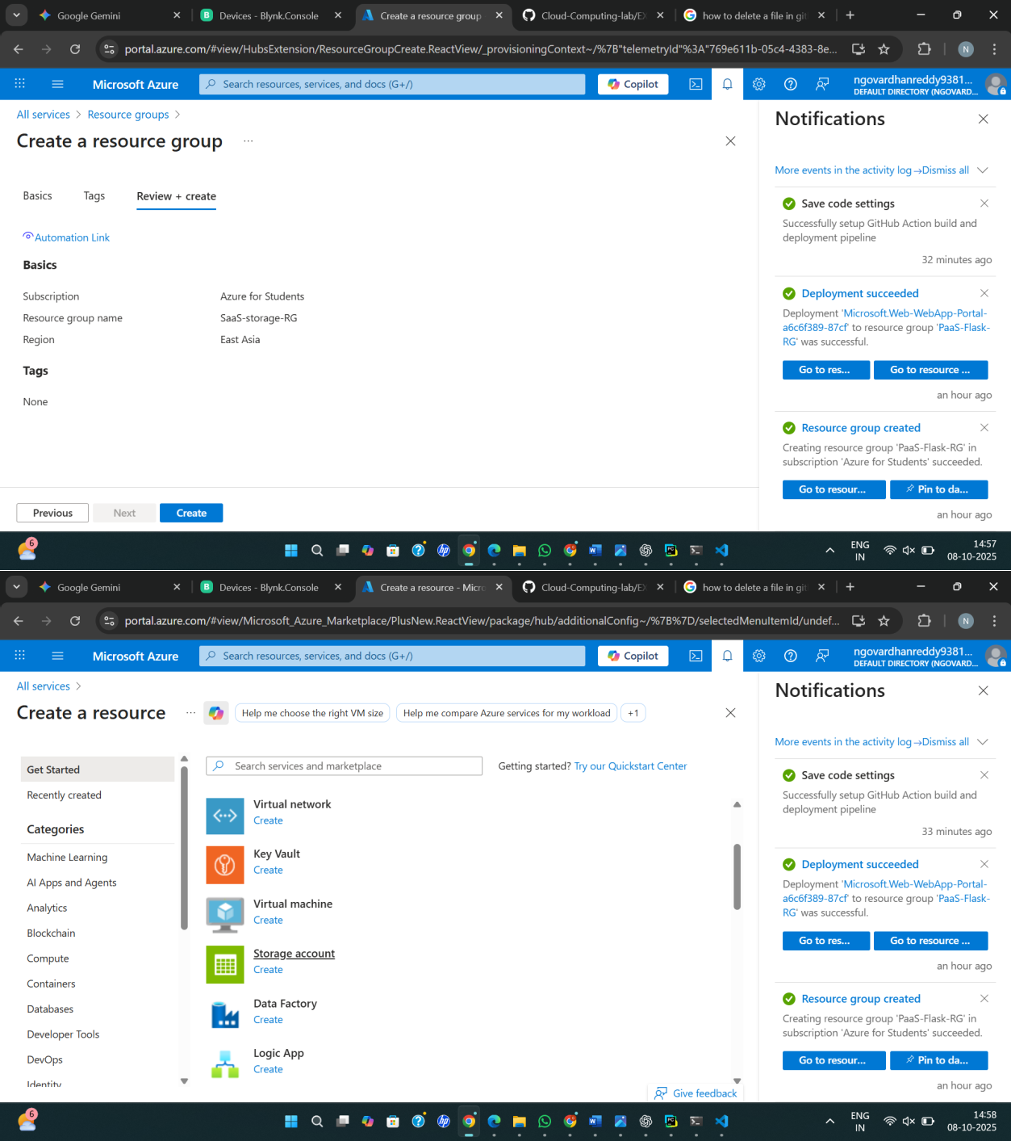

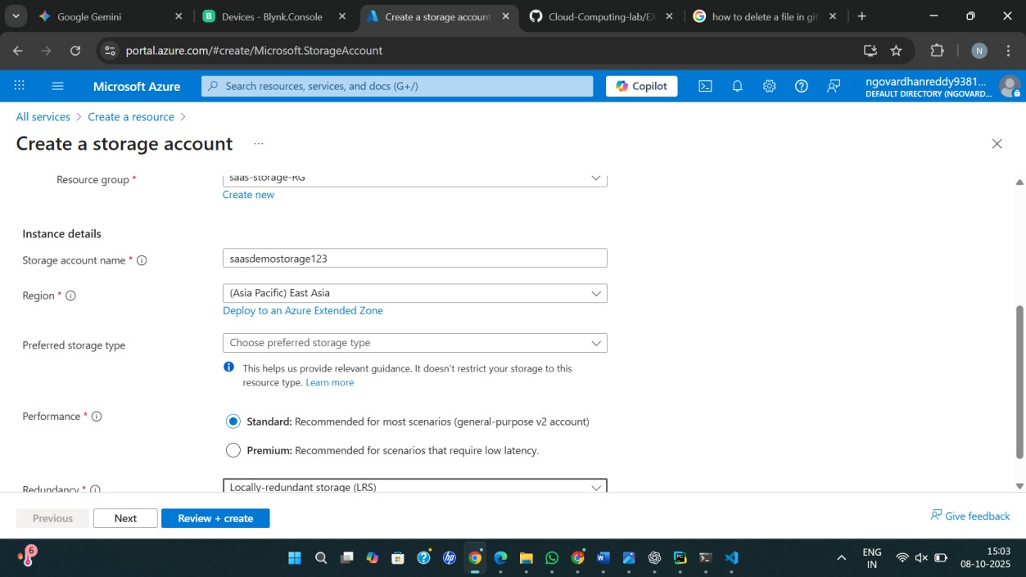

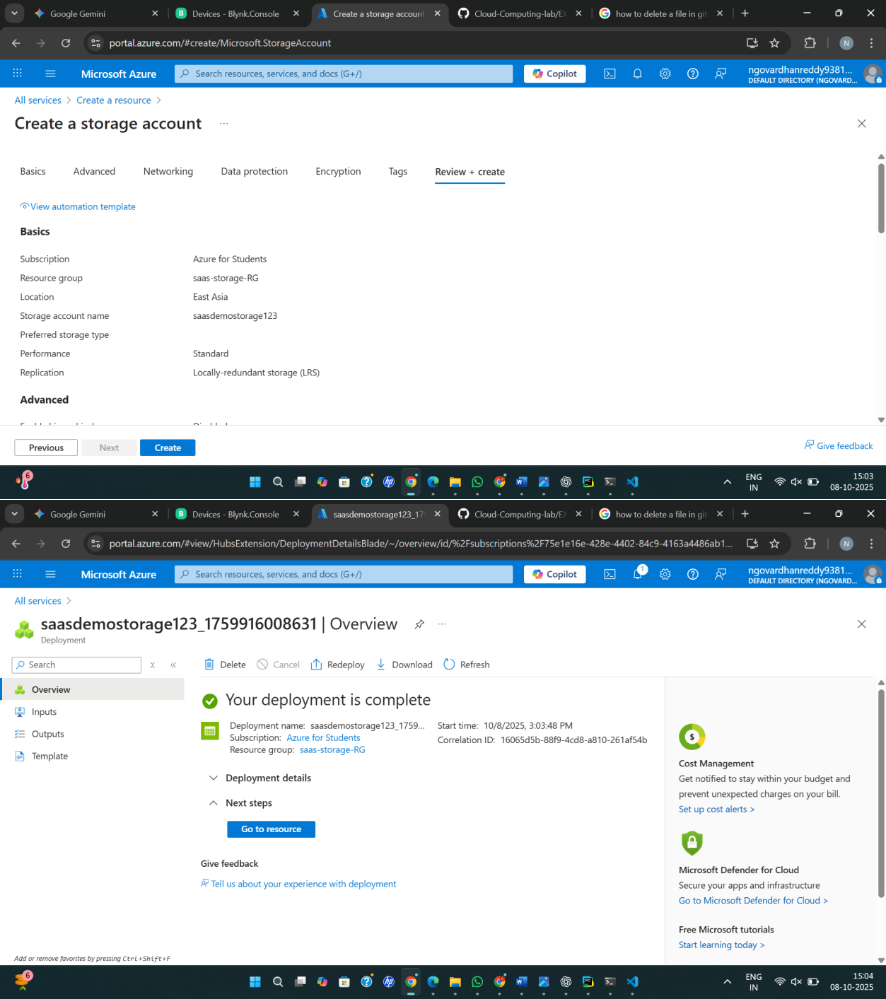

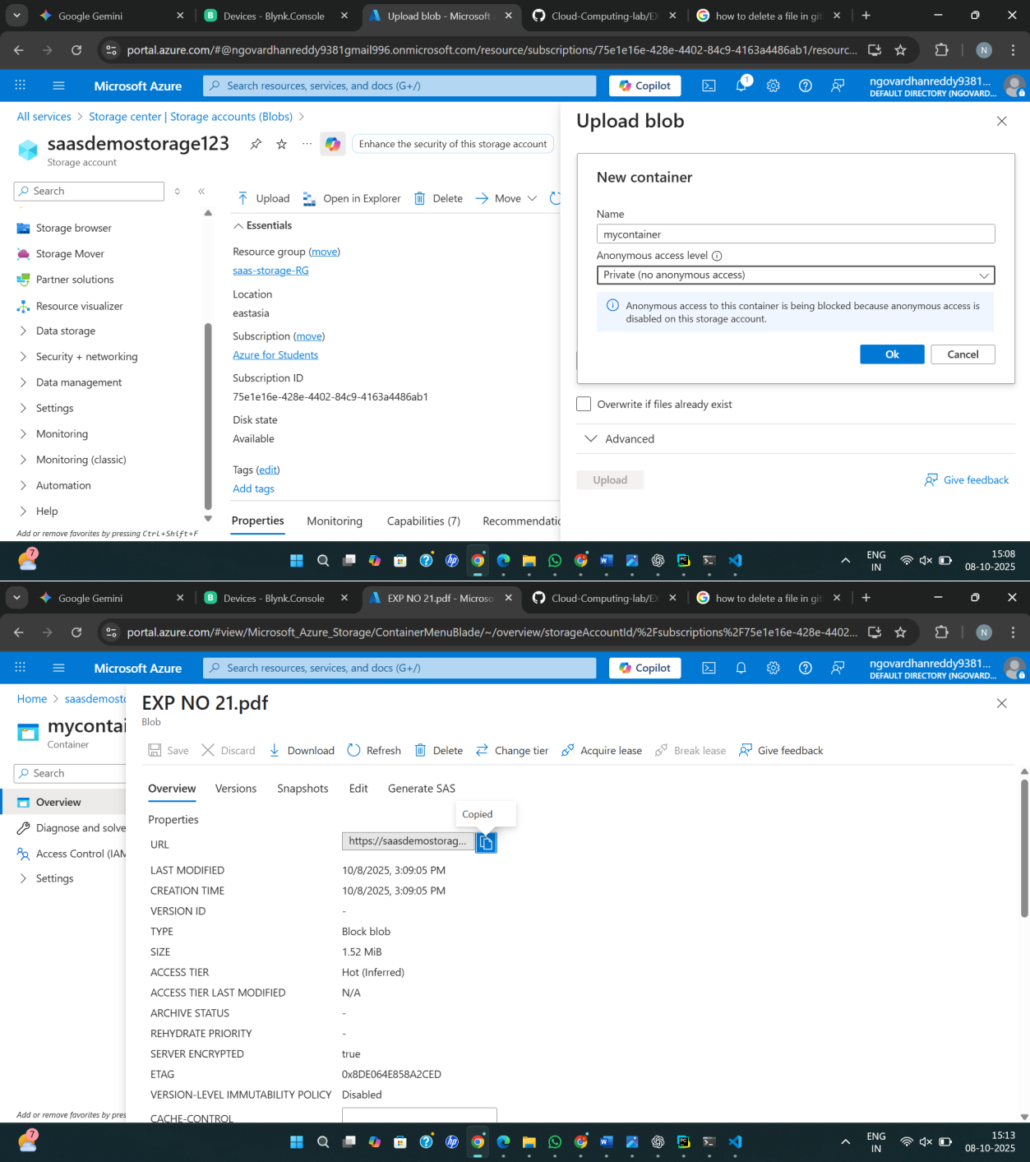

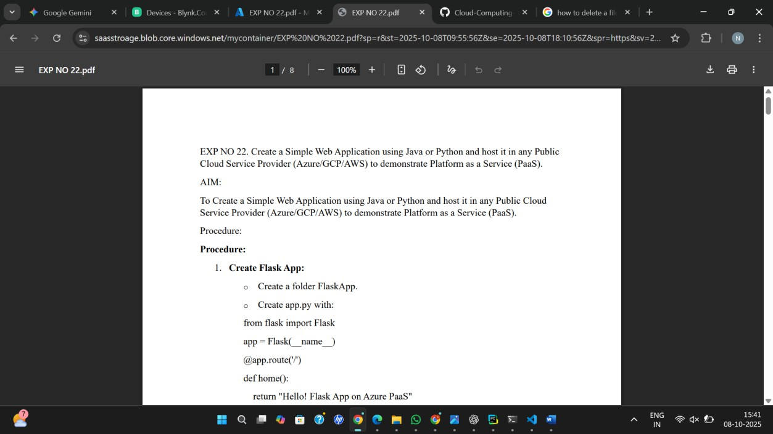
Result:
Azure Storage was successfully created and files were uploaded, demonstrating Storage as a Service (SaaS).

